Narrative Nonfiction
000s - Computer science, information, and general works
* In the DRHS Library collection
^ In the Henrico County Public Library collection
+ In either the HCPS or HCPL Sora collection - access via Clever (add the HCPL and set filter to ALL LIBRARIES)

Tags | Cover | Author | Title - linked to book description | * DRHS library  ^ Henrico County Public Library  + Sora
Nonfiction, business & economics, statistics, Social Psychology, Mathematics | 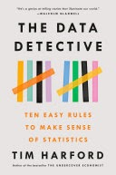 | Tim Harford | The Data Detective: Ten Easy Rules to Make Sense of Statistics | *  ^
Nonfiction, Political Science, Political Ideologies, Psychology, Social Science, conspiracy theories | 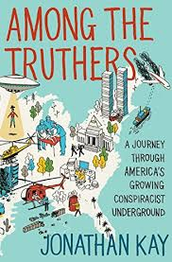 | Jonathan Kay | Among the Truthers: A Journey through America's Growing Conspiracist Underground | *  ^
Nonfiction, popular culture, unexplained phenomena, extraterrestrial beings, government information | 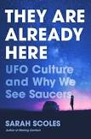 | Sarah Scoles | They Are Already Here  UFO Culture and Why We See Saucers | *  ^
Nonfiction, history, hoaxes, curiosities & wonders, law & crime | 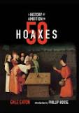 | Gale Eaton | History of Ambition in 50 Hoaxes | *  ^
Nonfiction, technology, inventions | 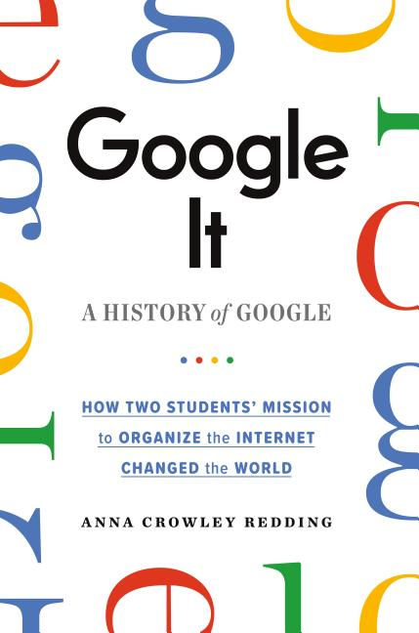 | Anna Crowley Redding | Google It: A History of Google | *  ^
Nonfiction, business & economics, information technology, artificial intelligence, computer scientists, search engines, social media, machine learning | 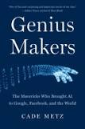 | Cade Metz | Genius Makers  The Mavericks Who Brought AI to Google, Facebook, and the World | *  ^
Computers & coding, STEM, social issues, sociology, technology | 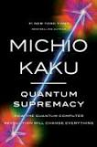 | Michio Kaku | Quantum Supremacy  How the Quantum Computer Revolution Will Change Everything | *  ^
Nonfiction, computers, technology, artificial intelligence | 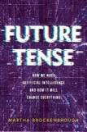 | Martha Brockenbrough | Future Tense  How We Made Artificial Intelligence—and How It Will Change Everything | *  ^  +
Nonfiction, artificial intelligence, human-computer interaction (HCI), technology & Engineering | 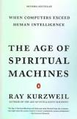 | Ray Kurzweil | The Age of Spiritual Machines  When Computers Exceed Human Intelligence | *  ^
Nonfiction, computers, artificial intelligence, Computer Science, Technology & Engineering, inventions | 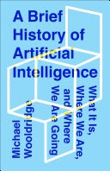 | Michael Wooldridge | A Brief History of Artificial Intelligence: What It Is, Where We Are, and Where We Are Going | *
Biography, technology, social media, business | 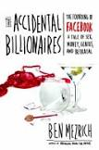 | Ben Mezrich | The Accidental Billionaires  The Founding of Facebook: A Tale of Sex, Money, Genius and Betrayal | *  ^
Nonfiction, true crime, history, arson, Los Angeles, public libraries | 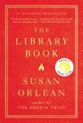 | Susan Orlean | The Library Book | *  ^
Nonfiction, history, Cold War, Poland, Russia, propaganda, information warfare, censorship, banned books, reading, ideas | 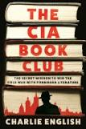 | Charlie English | The CIA Book Club  The Secret Mission to Win the Cold War with Forbidden Literature | *  ^

